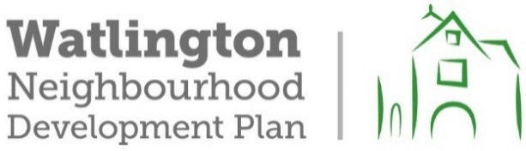

Watlington Parish Council

Neighbourhood Plan Advisory Board
Report on the informal consultation on the draft policies in the WNDP review held in July and August 2023.
- The consultation was held in two parts:
- Drop-in sessions at the Watlington Club on Friday 21st July from 6.00p.m. to 8.00p.m. and on Saturday 22nd July from 10.00a.m. to 12 noon.
- An online survey from 17th July. The end date of 31st July was extended to 15th August at the request of the Watlington Business Association.
- Approximately 1400 leaflets advertising the consultation were delivered by local volunteers to households throughout the parish (the parish boundary is also the boundary of the Watlington Neighbourhood Plan area). Information on the consultation was also placed on the Parish Council’s website and posted on Facebook on the Watlington Notice Board site. Copies of the consultation documents and paper copies of the survey were available in the parish office and in Watlington Library throughout the consultation period.
- Originals of all the consultation documents and the responses are available at the parish office on request.
- Drop-in Sessions:
The drop-in sessions were attended by about 20 people on Friday 21st July and about 65 people on Saturday 22nd July. The local residents who attended engaged very positively in the consultation and there were very useful conversations about the delivery of the housing development allocated in the existing Neighbourhood Plan (made in 2018) and progress towards the construction of the edge road (now called the Watlington Relief Road). Responses to the draft policies were positive. One attendee put his finger on the challenge of drafting policies by saying that the objectives of the policies are difficult to disagree with – the difficulty comes with trying to deliver them. Several people made comments on post-it notes which were all constructive.
- Online Survey:
82 individuals responded - 78 online and 4 on paper
Not everyone responded to every question.

Policies to protect and enhance the historic character of Watlington, its landscape and the small settlements within the Neighbourhood Plan boundary:
Yes – I support these policies: 65 = 87%
No – I do not support these policies: 10 = 13%

Policies for the Environment
Yes – I support these policies: 69 = 86%
No – I do not support these policies: 10 = 13%
Neutral 1 = 1%

Policies for Design:
Yes – I support these policies: 69 = 86%
No – I do not support these policies: 10 = 13%
Neutral: 1 = 1%

Policies for Housing
Yes – I support these policies: 55 = 79%
No – I do not support these policies: 12 = 17%
Neutral: 3 = 4%

Policies for Transport and Sustainable Travel
Yes – I support these policies: 53 = 80%
No – I do not support these policies: 10 = 15%
Neutral: 3 = 5%

Policies for the Local Economy
Yes – I support these policies: 68 = 84%
No – I do not support these policies: 10 = 12%
Neutral: 3 = 4%

Policies for Physical and Social Infrastructure
Yes – I support these policies: 69 = 84%
No – I do not support these policies: 10 = 12%
Neutral: 3 = 4%

Question 8 provided space for any additional comments. 44 comments were made. These largely reflect the comments made on the individual policies.

Summary:
A large majority of the people who contributed to the consultation support the draft policies in the revised Neighbourhood Plan. Some constructive and useful comments were made and all comments will be taken into account. The outcomes of the consultation will be considered by the Neighbourhood Plan Advisory Board and the Parish Council. Any amendments to the policies as a result of the consultation will be reported as the review of the Neighbourhood Plan progresses.

